|  |  |
| --- | --- |
| **Lab Questions 2** | |
|  |
| **Course Code: CSE 107** |
|  |

1. *(Employee Class)* Create a class called Employee that includes three pieces of information asdata members—a first name (type string), a last name (type string) and a monthly salary (typeint). [*Note:* In subsequent chapters, we’ll use numbers that contain decimal points (e.g.,2.75)—called floating-point values—to represent dollar amounts.] Your class should have a constructor that initializes the three data members. Provide a *set* and a *get* function for each data member.If the monthly salary is not positive, set it to 0. Write a test program that demonstrates classEmployee’s capabilities. Create two Employee objects and display each object’s *yearly* salary. Thengive each Employee a 10 percent raise and display each Employee’s yearly salary again.

Sample Output:

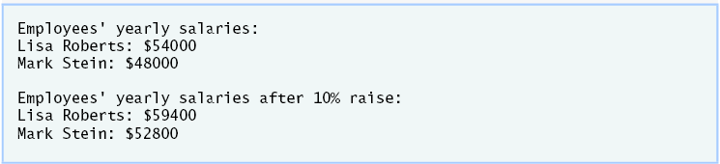

2. *(Date Class)* Create a class called Date that includes three pieces of information as data members—a month (type int), a day (type int) and a year (type int). Your class should have a constructorwith three parameters that uses the parameters to initialize the three data members. For the purposeof this exercise, assume that the values provided for the year and day are correct, but ensure that themonth value is in the range 1–12; if it is not, set the month to 1. Provide a *set* and a *get* function foreach data member. Provide a member function displayDate that displays the month, day and yearseparated by forward slashes (/). Write a test program that demonstrates class Date’s capabilities.

Sample Output:

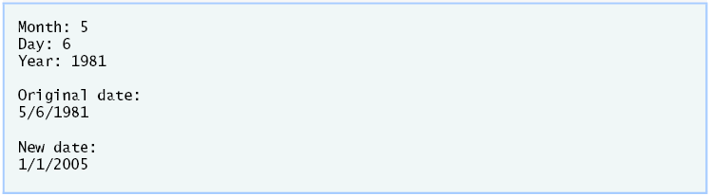

(3) Develop an Object Oriented Program that uses a *while statement* to determine the gross pay for each of several employees. With an hourly rate of 10.00, the company pays “straight time” (hours*rate) for the first 40 hours worked by each employee. The company pays “time-and-a-half” for all hours worked in excess of 40 hours [40.0 * rate + (hours - 40.0) * rate * 1.5]. Note that, if an employee works exactly 55 hours, that employee receives a $100 bonus, but no longer receives overtime for the number of hours worked over 40. But, if the employee works 75 hours or more, that employee receives a $1000 bonus in addition to overtime. The pseudocode of nested *if...else* structures are given below.

Sample output:

Enter hours worked (-1 to end): 39

Salary is $390.00

Enter hours worked (-1 to end): 40

Salary is $400.00

Enter hours worked (-1 to end): 41

Salary is $415.00

Enter hours worked (-1 to end): 55

Salary is $500.00

Enter hours worked (-1 to end): 56

Salary is $640.00

Enter hours worked (-1 to end): 75

Salary is $1925.00

Enter hours worked (-1 to end): -1

(4) Drivers are concerned with the mileage obtained by their automobiles. One driver has kept track of several tankfuls of gasoline by recording miles driven and gallons used for each tankful. Develop an Object Oriented Program that uses a while statement to input the miles driven and gallons used for each tankful. The program should calculate and display the miles per gallon obtained for each tankful and print the combined miles per gallon obtained for all tankfuls up to this point.

Enter miles driven (-1 to quit): **287**

Enter gallons used: **13**

MPG this tankful: 22.076923

Total MPG: 22.076923

Enter miles driven (-1 to quit): **200**

Enter gallons used: **10**

MPG this tankful: 20.000000

Total MPG: 21.173913

Enter the miles driven (-1 to quit): **120**

Enter gallons used: **5**

MPG this tankful: 24.000000

Total MPG: 21.678571

Enter the miles used (-1 to quit): **-1**